

**Outlook Profile Update Utility (CPUU) Story Board**

Date: July 26, 2016

This document contains confidential and proprietary information of Avanade and may be protected by patents, trademarks, copyrights, trade secrets, and/or other relevant state, federal, and foreign laws.  Its receipt or possession does not convey any rights to reproduce, disclose its contents, or to manufacture, use or sell anything contained herein.  Forwarding, reproducing, disclosing or using without specific written authorization of Avanade is strictly forbidden.

The Avanade name and logo are registered trademarks in the US and other countries.  Other brand and product names are trademarks of their respective owners.

**Document Information**

|  |  |
| --- | --- |
| **Documentation For:** | **Synchrony Financial Bank** |
| File Name: | Outlook Profile Update Utility (CPUU) Story Board V 1 |
| Author(s): | Arifur Rahman |
| Team: | Avanade Inc |

**Document Revision History**

|  |  |  |  |
| --- | --- | --- | --- |
| **Version** | **Date** | **Changed By** | **Change** |
| 1 | 05/22/2015 | Arifur Rahman | Initial version |
| 1.1 | 6/10/16 | Arifur Rahman | Updated popup message |
| 2.0 | 7/26/2016 | Arifur Rahman | Update the new CPUU MSI and URL |
| 2.1 | 08/01/2016 | Arifur Rahman | Update How to run CPUU and Disable SCPLookup |
|  |  |  |  |
|  |  |  |  |

**Document Sign-Off**

**Reviewed by:**

Customer Signature Date

# Introduction

The purpose of this document is to provide Outlook Profile Update experience using Dell CPUU utility tool.

# CPUU Distribution Options

* Distribute the CPUU files via Software distribution (SCCM) to client workstation
* Share the CPUU files on a remote share, CPUU scripts to pull the files down if does not exist locally

Notes: On both options end users story board will be the same.

# End User Story Board

| Steps | Screen Shot |
| --- | --- |
| 1. Click on the URL    1. CT user click on CPUU-CT    2. DTZ user click on CPUU-DTZ | **CPUU-CT:**  [**https://cushwake1-my.sharepoint.com/personal/gtsprojectunity_cushwake_com/_layouts/15/guestaccess.aspx?guestaccesstoken=fhpMWidcfhI%2bahdxvSg3%2bbMwH9BI%2fMc4nQMcFMoSDHY%3d&docid=2_070995d1e97144d739ea94b63fbdfcae2&rev=1**](%20https:/cushwake1-my.sharepoint.com/personal/gtsprojectunity_cushwake_com/_layouts/15/guestaccess.aspx?guestaccesstoken=fhpMWidcfhI%2bahdxvSg3%2bbMwH9BI%2fMc4nQMcFMoSDHY%3d&docid=2_070995d1e97144d739ea94b63fbdfcae2&rev=1%20)  **CPUU-DTZ:**  [**https://cushwake1-my.sharepoint.com/personal/gtsprojectunity_cushwake_com/_layouts/15/guestaccess.aspx?guestaccesstoken=7ml7RrNMW7Mu6uTQxm7vptU9HSEGYw4ZAPrwZHvdXLc%3d&docid=2_0ffd2ab006c4c4ea2856d08153ccc587e&rev=1**](https://cushwake1-my.sharepoint.com/personal/gtsprojectunity_cushwake_com/_layouts/15/guestaccess.aspx?guestaccesstoken=7ml7RrNMW7Mu6uTQxm7vptU9HSEGYw4ZAPrwZHvdXLc%3d&docid=2_0ffd2ab006c4c4ea2856d08153ccc587e&rev=1) |
| 1. Enter your CushWake credentials    1. Email Address    2. Password 2. After you enter your credentials download will start autumnally |  |
| 1. Locate downloaded file **OutlookMigrationTool.msi** then double click to execute |  |
| 1. Outlook Migration Helper setup Click **Next** |  |
| 1. Installation folder keep the default setting and Click **Next** |  |
| 1. Click **Next** |  |
| 1. Click **Close** to complete the installation |  |
| 1. Verify shortcut is created on the desktop 2. Double click on the “Outlook Profile Update Tool” to start the update process |  |
| 1. If your Outlook is not compatible with Outlook Migration Tool, you will see popup message “We have detected that you need to update your current version of Office for your email migration to complete. Please follow the steps in the Microsoft Office update section to the Self-service Email Migration Tool user guide”. |  |
| 1. If your Outlook is not compatible with Outlook Migration tool, you will see popup message “We have detected that your Outlook is not supported by Outlook Migration Tool. Please follow the instructions in the Manual Email Migration Guide linked in the communication you received.” |  |
| 1. If hidden message is found, you will see popup message “Your mailbox is about to be migrated to C&W Office 365. Please save all your work. Profile update Tool will configure your new Outlook. DO NOT LAUNCH ANY APPLICATIONS UNTIL OUTLOOK PROFILE UPDATE IS COMPLETE!” |  |
| 1. If you user Click **“OK”** All the MAPI application will be close (Outlook, Skype) and CPUU process will start. If not by default message will be close after 2 minutes and CPUU process will start |  |
| 1. User will see popup message After Outlook Process updated “Your mailbox has been successfully migrated” |  |
| 1. When user Open Outlook It will be pointed to C&W Office 365 Mailbox and re-download the Mail to local .ost |  |

# How to re-run CPUU?

1. Check for the following Registry key, if exist deleted the “OutlookUpdated” folder

HKCU\Software\OutlookUpdated

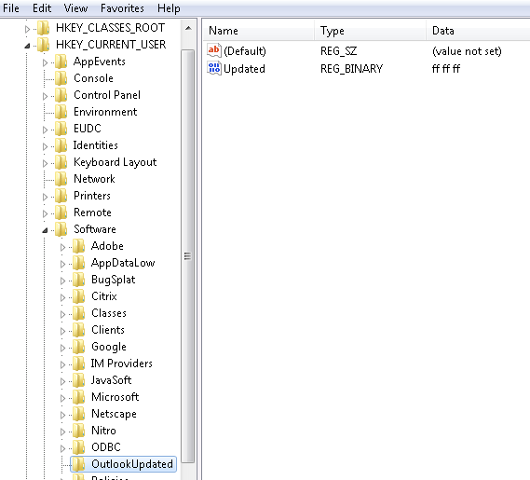

1. Follow the instruction above to Re-install the **OutlookMigrationTool.msi** and Run the **“Outlook Profile Update Tool”**

# How to Disable SCP Lookup?

**Note:** the SCP is used by domain joined clients to locate the Autodiscoer service. Changing the registry value force Outlook to exclude the SCP check. So this doesn’t interfere with legacy exchange autodiscover.

HKEY_CURRENT_USER\Software\Microsoft\Office\x.0\Outlook\AutoDiscover

Create DWORD (32-bit) Value

Value Name: ExcludeScpLookup

Value data: 1

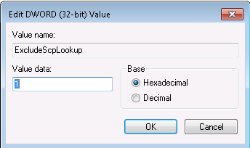

(Outlook version (16.0 = Outlook 2016, 15.0 = Outlook 2013, 14.0 = Outlook 2010)